|  |
| --- |
| BSHC4, BSHCE4, BSHBIS4, BSHBISE4 |
| Requirements Specification (RS) |
| Fight Utopia |

|  |
| --- |
| Sean Hoey x11000759  11/3/2014 |

Requirements Specification (RS)

Document Control

Revision History

|  |  |  |  |  |  |
| --- | --- | --- | --- | --- | --- |
| **Date** | **Version** | **Scope of Activity** | **Prepared** | **Reviewed** | **Approved** |
| 03/11/2014 | 1 | Create |  |  |  |
|  |  |  |  |  |  |

Distribution List

|  |  |  |
| --- | --- | --- |
| **Name** | **Title** | **Version** |
| Paul Stynes | Project Supervisor |  |
|  |  |  |
|  |  |  |
|  |  |  |
|  |  |  |

Related Documents

|  |  |
| --- | --- |
| **Title** | **Comments** |
| Title of Use Case Model |  |
| Title of Use Case Description |  |

**Table of Contents**

1 Introduction 3

1.1 Purpose 3

1.2 Project Scope 3

1.3 Definitions, Acronyms, and Abbreviations 3

2 User Requirements Definition 4

3 Requirements Specification 4

3.1 Functional requirements 4

3.1.1 Use Case Diagram 5

3.1.2 Requirement 1 <New Game> 5

3.1.3 Requirement 2 <Load Game > 6

3.1.4 Requirement 3 <Quit> 7

3.2 Non-Functional Requirements 8

3.2.1 Performance/Response time requirement 8

3.2.2 Availability requirement 9

3.2.3 Robustness requirement 9

3.2.4 Reliability requirement 9

3.2.5 Maintainability requirement 9

3.2.6 Extendibility requirement 9

3.2.10 Reusability requirement 9

3.2.11 Resource utilization requirement 9

4 Interface requirments 9

4.1 GUI 10

5 System Architecture 8

6 System evolution 8

# Introduction

## Purpose

This document is to set out the requirements for the development of my project Fight Utopia. Fight Utopia is a third person open world fighting roleplaying game, where you play in a world rule but the best fighters as you fight to become the best and end the senseless violence.

The intended customers are individuals who enjoy playing videogames above the age of sixteen or older. It will be intended to individuals who enjoy fighting game along with an open world to explore and collect items for special items.

## Project Scope

The scope of the project is to develop a full working video game. The system shall have:

* A city made in unity,
* A character created in Autodesk Maya,
* Building created in Autodesk Maya,
* Enemies and NPC created in Autodesk Maya,
* Combat system,
* Inventory,
* Animations,
* Fast travel.

Some of the constraints I have about the project is the amount of time I but into the game writing code and creating models in Autodesk Maya.

## Definitions, Acronyms, and Abbreviations

AD - Another Definition

FU - Fight Utopia

GUI – Graphical User Interface

AI – Artificial Intelligence

RPG – Role Playing Game

OW – Open World

RAM – Random Access Memory

NPC – Non Playable Characters

EXP – Experience points

VR –Virtual Reality

# User Requirements Definition

The system Requirements from a user side include:

* User has a computer.
* User has a ps3 controller.
* Windows Operating system.
* Fight Utopia downloaded onto the computer.

# Requirements Specification

All requirements should be verifiable. For example, experienced controllers shall be able to use all the system functions after a total of two hours training. After this training, the average number of errors made by experienced users shall not exceed two per day.

## Functional requirements

This section lists the functional requirements in **ranked order**.

|  |  |
| --- | --- |
| **Requirements** | **Description** |
| Play Game | The player has to be able to play the game all functions working and have no game breaking bugs. |
| Level up | As the player defeats enemies they should gain experience to level up. This Allows the player to develop skills and gain combat moves. |
| Combat System | This will allow the players to fight with the NPC and being the main focal point of the game. |
| Fight bosses and final bosses. | Fight bosses to unlock move parts of the map and to get to the final boss to complete the game. |
| Fast travel points | These are point on the map players will need to unlock to easily and quickly move across the map. |
| Save Game | Allow players to save their progress, level and unlocked skills. So that they can start up the game again and continue from where they left off. |
| Load Game | Allow players to load their save game and continue on from there. |

### Use Case Diagram

Each requirement should be uniquely identified with a sequence number or a meaningful tag of some kind.

The Use Case Diagram provides an overview of all functional requirements.

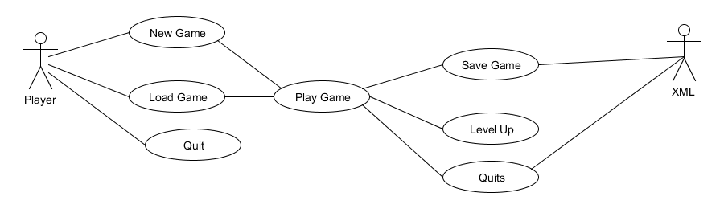

### Requirement 1 <New Game>

#### Description & Priority

The player needs to start a new game as if they haven’t played the game before they need to play the game from the start. If it’s a first time player the will need to start the game from the beginning

#### Use Case

**Scope**

The scope of this use case is to allow player to start a new game.

**Description**

This use case describes the steps involved in starting a new game

**Use Case Diagram**

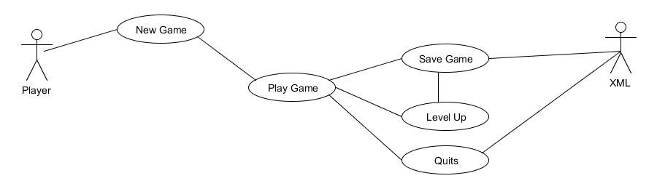

**Flow Description**

**Precondition**

The player has started up the game.

**Activation**

This use case starts when a player started up the game in the main menu.

**Main flow**

1. The player selects new game.
2. Player plays game.
3. Player levels up.
4. Game saves details to xml save file.
5. Player quits out of game.

**Termination**

The system presents the main menu when player quits out of the game.

**Post condition**

The system goes into a wait state

### Requirement 2 <Load Game>

#### Description & Priority

A returning player is allowed to select load game and continue on from where the last left off on their previously saved game.

#### Use Case

**Scope**

The scope of this use case is to allow player to load game.

**Description**

This use case describes the steps for a player to load a previous game.

**Use Case Diagram**

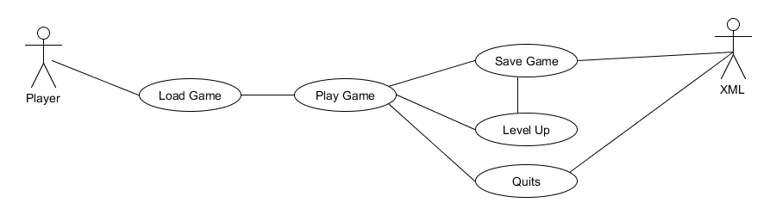

**Flow Description**

**Precondition**

The player has started up the game and has saved file of previous game.

**Activation**

This use case starts when a player started up the game in the main menu.

**Main flow**

1. The player selects Load game from main menu.
2. Player Plays game from where they left off.
3. Player levels up.
4. Game saves details to xml File.
5. Player quits out of game.

**Termination**

Game goes back to main menu.

### Requirement 4 <Quit>

#### Description & Priority

Player wants to leave game and exits the game.

#### Use Case

**Scope**

The scope of this use case is to allow players to quit.

**Description**

This use case describes the steps for a player to quit game.

**Use Case Diagram**

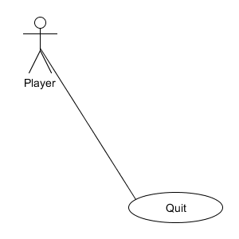

**Flow Description**

**Precondition**

The player has started up the game.

**Activation**

This use case starts when a plyer is in the main menu.

**Main flow**

1. Player selects quit game from main menu.
2. Game turns off and exit to computers home screen

**Termination**

Computer goes to home screen.

## Non-Functional Requirements

### Performance/Response time requirement

When making a game it is important that the game run perfectly and doesn’t slow down. Games need to run at a constant frame rate to ensure there is no lag to ensure smooth gameplay and animations.

Game needs to run perfectly as glitches or bug in games can ruin gameplay and make users less likely to play the game.

### Availability requirement

The game will be built in and for windows but I would like to port to other platforms like Xbox or PlayStation. I would have the game to be able to be downloaded through game streaming services such as steam, Xbox live and PlayStation Store

### Robustness requirement

When running the game should be able to play continuously and not crash.

### Reliability requirement

The game needs to work the same way and have the functionality across all platforms.

### Maintainability requirement

Games can be fixed and repaired through post-release patches downloaded online. These patches can fix and alter any bug, game breaking or exploits in the game. Players will also be able to report any and all bugs to developer to fix.

### Extendibility requirement

When the game is released it is possible to add on additional content through DLC (Downloadable Content). These DLC can contain additional levels not created for the main release or even other game modes.

### Reusability requirement

Games all have common code for movement and fighting if I were making another game. Common scripts can be Collision detection, player movement, camera movement, Attacks and etc.

I wanted to continue development of the game or create a sequel; I could also reuse some of the art assets to keep the game in the same style.

### Resource utilization requirement

The Game will use as much available resources as it requires from the users system to produce a standard of stability and playability.

# Interface requirements

Fight Utopia will be interfaced with an xml file that saves the players stats. I know saving to an xml file isn’t the best approach but I would like to host the game online or even just an online high Score list which the xml file will help to do. I am also working with the oculus rift api to allow my game to be use through the VR head set

## GUI

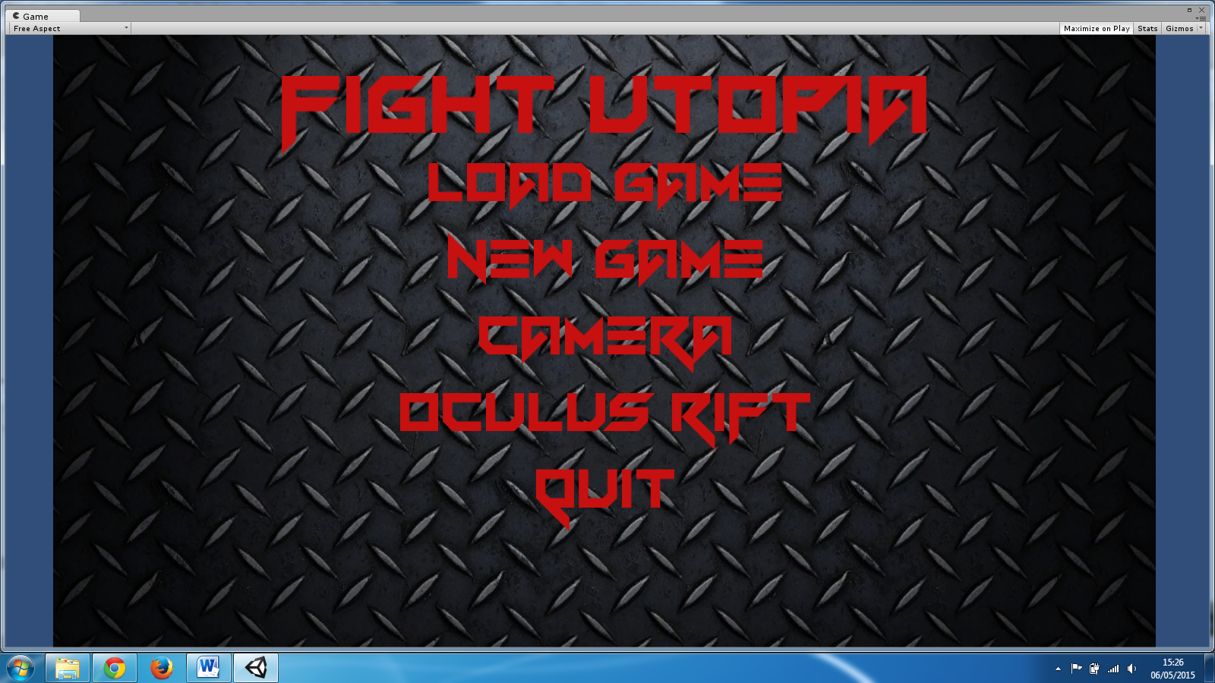

This is the GUI for my main menu, It’s a very simple GUI the load Game and Start game lead you to the fame itself and quit exits out application.

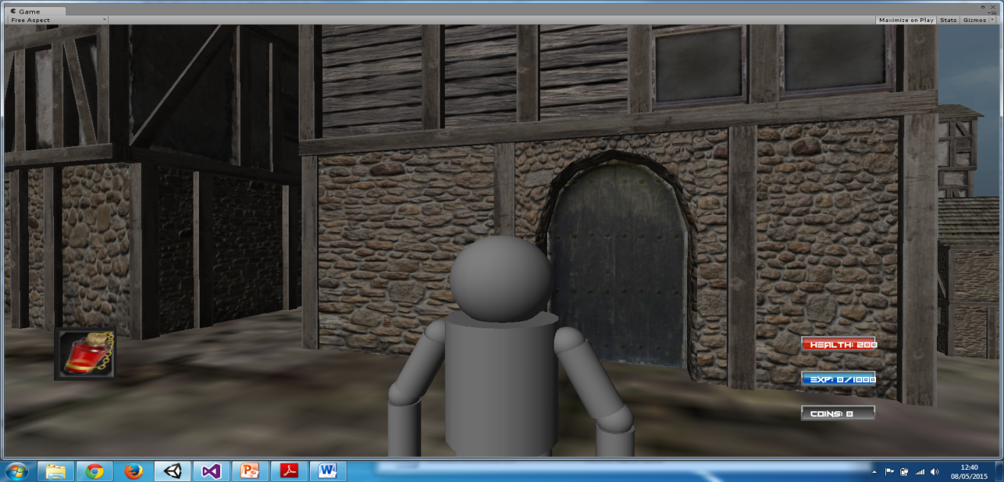

GUI in the with the item your using on the lower left side of the screen. Along with your health, experience points and coins on the lower right side.

# System Architecture

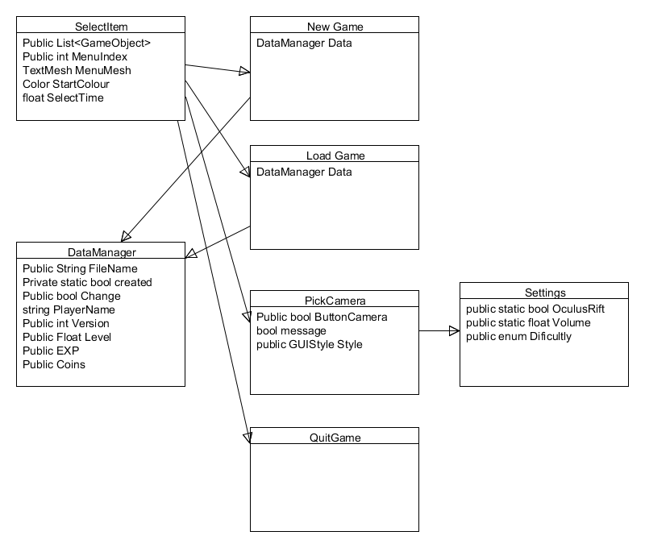

Here is the Class diagram for main menu above.

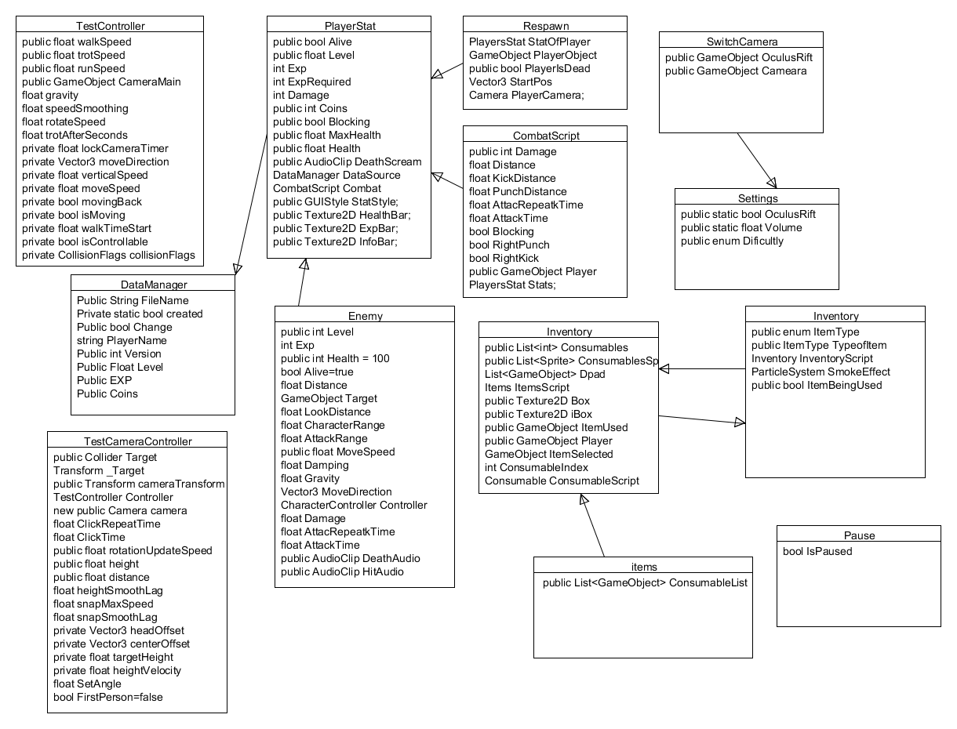

This is the Class diagram for the main game.

# System Evolution

I believe this game might do better as a massive online RPG where players from around the world can fight with or against players from around the world.